**Learning Objectives**

● Summarize the negative effects of climate on weather

● Explain why climate affects weather (Temperature on Oceans)

Are Storms Getting Stronger? 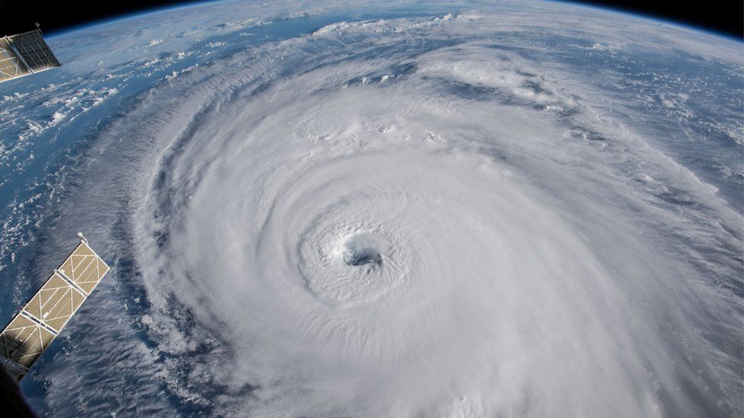

(Photo of Hurricane Florence heading towards East Coast )

Our lifestyles require an incredible amount of energy to sustain. The processes by which we obtain that energy is harming the environment. For the most part, energy is generated by the burning of fossil fuels and other energy sources to generate electricity. And with electricity, we can power all aspects of society. The exception of burning fossil fuels is that burning causes CO2 to be released, which is known to have concerning effects on the atmosphere and environmental systems. CO2 is a greenhouse gas, meaning that it absorbs and keeps more energy than other gasses in the atmosphere. Since it absorbs and holds more energy, it can, in excessive amounts, cause the entire planet to begin heating up. The effects of heating up are already becoming evident as data shows the earth has globally increased by two degrees. At first, that doesn’t seem like much, but such differences can throw very delicate systems out of order. One of these systems is the process and formation of storms.

Increasing temperature can cause hurricanes to increase in destructive capability significantly. Hurricanes gain their power through heat and steam coming off of the ocean. And an increase in overall temperature means more heat from the sea, which in turn increases a hurricane’s potential power. Researchers have already begun to see the possible effects of climate change on storms. When using 22 hurricane prediction models -models that guess a hurricane's path-, each one predicted an increase in hurricane power with increasing temperature. The significance of increased strength is the amount of damage done to homes and cities. Each year alone, hurricanes result in nearly one billion dollars in damage and contribute to many lost lives. Even more concerning is that modern research is confirming the prediction of these models through the behavior of thunderstorms. Data originating from the 1980s and forward has shown a slight increase in convective storms -aka thunder storms- power over time. The data is most evident in the midwest and southern planes of the United States, which are the central forming locations for storms. As well as increased storms, there has been an increased amount of hail days in the United States. While it’s not confirmed the increased hail is a result of increased temperatures, it’s most definitely a side effect of it.

**Winter Storms**

Thunderstorms, however, are not the only storm to see an increase in strength. Data resulting back to the 1950s shows an overall increase in frequency and intensity for winter storms. The data shows a correlation between increased temperature and the movement of tracks towards the north, which is the wind that controls the direction of storms. With that leads onto another concerning point of evidence, which is the change of atmospheric rivers. Atmospheric rivers are quite literally what they mean; they are rivers in the atmosphere. These rivers account for 90% of the poleward moisture that gets transported across the center of the earth. The significance of the atmospheric rivers is that they are a massive controlling factor in storms and the primary water source for the western United States. The movement of these tracts can cause an increase in droughts as well as an increase in extreme weather.

**The Difficulty With Storm Data**

However, most of the critical findings for the data of increasing storm strength lacks depth. Due to the limitations of earlier weather technology, many of the essential variables in calculating storms 50 years ago could not be collected. As a result, most of the historical cyclone data does not contain enough data to draw a proper well developed scientific conclusion. With that, it makes it very difficult to state for sure that climate change has been the primary factor for increasing storm power. However, there is still enough data to safely assume that it is of moderate probability that increased temperature has caused an increase in storm power.

Another area of the challenge lies in seeing if the instances of extreme storms correlate to the increase in global temperature. The problem is how rare most extremes storms are. They happen promptly and occur at most once or twice a year. It’s challenging because there are not enough instances of extreme storms to make a proper conclusion. But still, it’s a little weird in the past three years we’ve had two hurricanes at 185mph back to back when they are supposed to occur once a decade at most. As rare as extremes storms are, they have happened more in the 2000s than any other previous century.

1. What is the main cause for the plant warming up?
2. Nitrous
3. Carbon
4. Carbon Dioxide
5. Oxygen
6. CO2 is a _______
7. Greenhouse Gas
8. Fossil Fuel
9. Plasma
10. Electrical Conductor

3. Which of the following can increase a hurricanes strength

1. Sharks
2. Heat coming from the ocean
3. Fossil Fuels
4. Sun rays

4. What are Atmospheric Rivers

1. Rivers in the atmosphere
2. Oceans in the atmosphere
3. Rivers on land that evaporate excessive water into the atmosphere
4. The host for exotic fish

5. Why is past storm data not very useful

1. Because boats lacked proper sonar
2. Storms didn't exist then
3. Because the sky was blue
4. Past technology lacked proper instruments to collect important data

6. What are convective storms

1. Tornados
2. Hail
3. Thunderstorms
4. Blizzards